Essential Information Document and Application Form

Contents:
Page 1: Essential Information Document
Page 3: Application Form

Essential Information Document
Discover Campaign: Development of Novel Drugs for the Modulation of Innate Lymphoid Cells (ILCs)

Commissioning company: Global Pharmaceutical Company (anonymous)

Funding available: €750 (or $830k if based in North America)

Deadline: Monday 24th February 2020 (12pm local time)

Contents:

- Application process and timeline overview
- Success criteria
- Eligibility criteria
- Essential information on IP
- Publication and presentation of results

- Application process and timeline overview

Submission

- Academic teams must complete and submit the application form associated with the campaign by Monday 24th February 2020 at 12pm your local time.
- All submissions should be provided to IN-PART using your university’s online dashboard or by emailing: discover@in-part.co.uk
- IN-PART will acknowledge receipt of your submission once received.
Review

- IN-PART will provide the client with all applications received. The client team will review all applications by Thursday 9th April 2020
Successful applicants

- Successful applicants, alongside a representative from their university’s Technology Transfer or Research Commercialisation team, will be informed by IN-PART, and introduced to the team at the client company for next stage discussions

Unsuccessful applicants

- Feedback on unsuccessful applications will be provided by IN-PART shortly after Thursday 9th April 2020.

- Success criteria

Our client will judge each submission against the following criteria:

- Feasibility of research: is the proposal achievable within the funding time period?
- Originality of approach: is the proposal more than a “me-too” offering, does it differentiate from other research being undertaken in the area?
- Effectiveness of the approach: is there preliminary data or evidence to suggest the approach will be successful in a future clinical setting?
- Research team capability: what is the relevance of the background of researchers involved?

- Eligibility criteria

- Applicants must be working within the field of innate immunity and inflammatory diseases
- Please review the Discover campaign in detail to ensure your application fulfils the criteria for a successful applications.

- Essential information on IP

- Existing intellectual property rights will not be transferred (retained by the original holders).
- In principle, the joint research results will be co-owned and intellectual property from the joint research will be co-owned and jointly filed (shared with an ownership ratio based on the degree of contribution).
- We will retain the first refusal rights of the exclusive license for the joint research findings

- Publication and presentation of results

- a notification is required before publications. Furthermore, publications may be delayed until a patent application is registered if both parties agree that a patent application is deemed beneficial.

RFP Application Form

Important notes about submitting this application form:

- Please ensure you review the Terms and Conditions associated with this campaign.
- Only submit non-confidential information.
- You can find a copy of the respective campaign, including specific criteria for inclusion in your submission, at the end of this document.

Once completed, please submit this form using either method below:

- For universities subscribed to IN-PART: please upload a completed version of this document as a ‘Research Project’ under the correct ICO heading within your IN-PART Dashboard.

- For universities not subscribed to IN-PART: please email a completed version of this document to discover@in-part.co.uk (you will be notified by email receipt that we have successfully received your submission).

If you have any questions regarding the completion or submission of your application, or any other aspect of the Discover process, please do not hesitate to reach out to discover@in-part.co.uk. Additionally, answers to university FAQs can be found here.

Thank you for participating in this Discover campaign!

Please cross the box to confirm that you have read the essential information document ☐

Project Title

Title should be no longer than 20 words.

Principal Investigator Contact Information

Name:
Title:

Email:

Phone:

Institution, Department, and Address:

Abstract

Please provide a summary of the research proposal, including: the overall goal; hypothesis; specific aims; clinical rationale; commercial potential (if known); and what is novel and innovative about your approach.

Abstract should be no longer than 250 words.

Therapeutic Opportunity Description

- What is the primary therapeutic area?

- What is the development stage? Please choose from: Discovery, target identification, target validation, hit generation, compound screening, lead generation, in vitro, in vivo, or preclinical validation.

- What is the therapeutic modality? Please choose from: small molecule compounds, mAbs, nucleotide (e.g. siRNA), fusion protein, recombinant protein and peptides.

- Have you developed experimental models to support the research? Please include details on: the type of model (in-vitro/in-vivo/ex-vivo etc.); and species (mouse, human-mouse, rat, etc.). Please also provide a brief description of the model, and the following, if applicable: similarities or differences to human pathology; possible limitations of the model; and key advantages over alternative models available.

- Please provide a brief description of the target/pathway and its link to human disease.

- Please describe any therapeutic candidates the investigator has generated against the target, including the mechanism of action. Include the known characteristics of the therapeutic candidate (such as affinity, specificity, potency, pharmacokinetics, etc.) If unavailable, please describe the preferred attributes of the therapeutic candidate.

Scientific Background and Rationale

- Please summarise the hypothesis, background science and rationale, work completed to date, and current stage.

- Please provide key evidence/data to support the hypothesis. This may include human genetics, human tissue, in vivo models, and preclinical proof of concept.

Research Plan and Milestones

Please provide a brief description of the research plan to be carried out to reach your goals. This should include your objectives and specific aims.

Budget, Resources, and Funding

Awardees can request up to €750k (or $830k if based in North America) total funding per project. This includes all expenses and indirect costs, etc.

With this in mind, please could you specify what the award money would be spent on?

IP and Legal Considerations

- Have you previously disclosed this technology to your technology transfer office?

1.a If yes, who is your Case Manager? Please include their email address.

- To the best of your knowledge, what is the prior art in this space? This could include publications, patent applications, and issued patents.

Research Team

- Please provide a brief biographical sketch of the principal investigator and a list of his or her key publications. An NIH format biosketch is acceptable.

- Please list other team members (if any), including collaborators, and describe their roles in the project. Please provide a brief biographical sketch of the co-investigators (including Title, Department, and Institution).

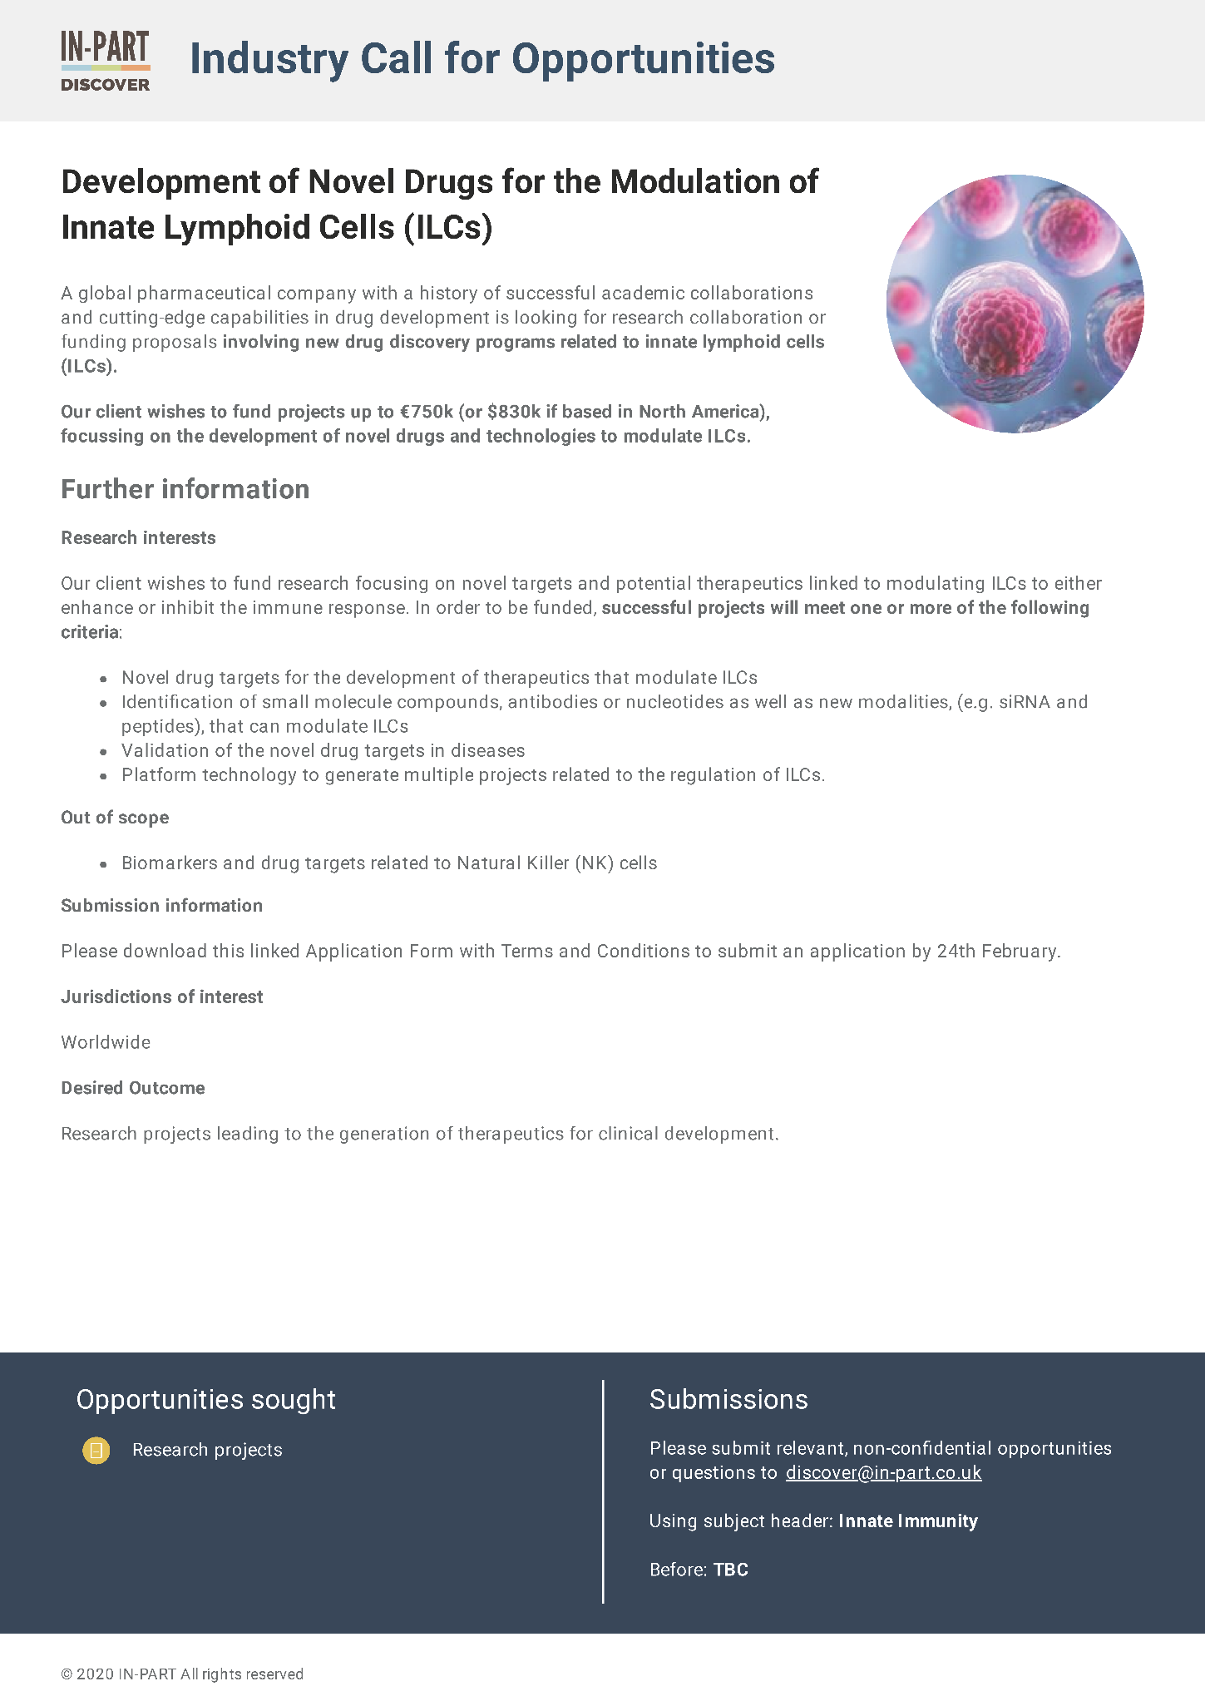
Appendix 1: Development of Novel Drugs for the Modulation of Innate Lymphoid Cells (ILCs)

